NAME: VIDULA R COURSE CODE: CSA1013
REG. NO: 192511270 COURSE NAME: SOFTWARE ENGINEERING

CO4 ASSESSMENT TOOL-2

TITLE: AI-Powered Smart Wastewater Treatment Monitoring System
CI/CD Pipeline Design Document

1. Project Overview
1.1 Problem Overview
Wastewater treatment plants require continuous monitoring of parameters such as pH, turbidity, dissolved oxygen (DO), temperature, and chemical oxygen demand (COD). Traditional manual monitoring can delay the detection of contamination, abnormal treatment conditions, and equipment failures.
The proposed system uses IoT sensors, AI/ML models, a backend application, database services, and a monitoring dashboard to collect and analyze wastewater data in real time. The system detects abnormalities, predicts treatment efficiency, provides maintenance alerts, recommends corrective actions, and generates compliance reports.
Because the system is expected to receive frequent updates to its application code, AI models, APIs, and monitoring components, a Continuous Integration and Continuous Deployment (CI/CD) pipeline is required to automatically test, validate, package, and deploy new versions.

2. Analyze the Project Requirements and Identify CI/CD Needs
The CI/CD pipeline must support the development and deployment of several components:
- Backend application.
- AI/ML prediction modules.
- Sensor-data processing modules.
- Database integration.
- REST APIs.
- Web monitoring dashboard.
- Automated reports.
- Docker containers.
The pipeline should ensure that every code change is tested before it reaches production.
2.1 Functional Requirements Affecting CI/CD
Requirement | CI/CD Need
Continuous sensor monitoring | Automated integration and API testing
AI anomaly detection | Automated model and prediction testing
Treatment efficiency prediction | ML validation tests
Predictive maintenance | AI module testing
Real-time dashboard | Frontend and API testing
Compliance reports | Report-generation testing
Equipment monitoring | Integration testing
Alerts and notifications | Automated notification testing
Database storage | Database integration testing
REST APIs | Automated API tests
2.2 Non-Functional Requirements Affecting CI/CD
Quality Attribute | CI/CD Requirement
Reliability | Automated testing and rollback
Security | Dependency and vulnerability scanning
Performance | Automated performance testing
Maintainability | Code quality analysis
Availability | Automated deployment and health checks
Scalability | Containerized deployment
Portability | Docker-based packaging
Accuracy | AI/model validation
Traceability | Git version control

3. CI/CD Requirements
The proposed pipeline should provide:
- Automatic pipeline execution after code commits.
- Source code version control.
- Dependency installation.
- Automated unit testing.
- API and integration testing.
- AI model validation.
- Code quality analysis.
- Security vulnerability scanning.
- Docker image creation.
- Container image scanning.
- Deployment to a development environment.
- Deployment to a staging environment.
- Approval before production deployment.
- Production deployment.
- Application health monitoring.
- Automatic rollback if deployment fails.
- Notifications about pipeline status.

4. Selected CI/CD Architecture
A Git-based CI/CD architecture using GitHub Actions and Docker is suitable for this project.
The overall architecture is:
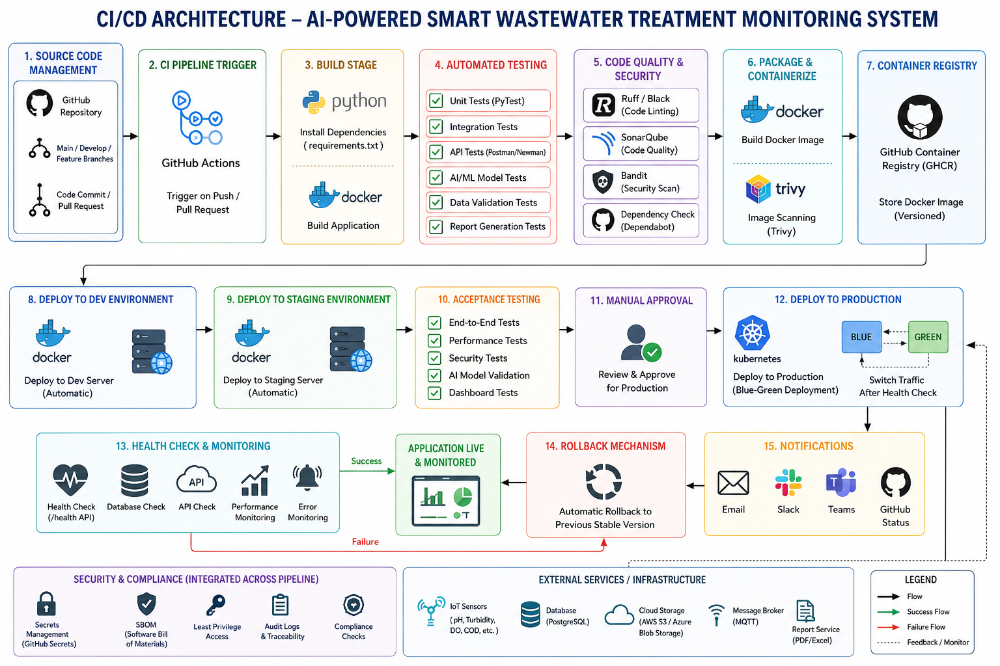

5. CI/CD Pipeline Workflow
The proposed pipeline consists of the following stages:
Code
↓
Source Control
↓
Build
↓
Unit Testing
↓
Integration/API Testing
↓
AI Model Testing
↓
Code Quality Analysis
↓
Security Scanning
↓
Docker Build
↓
Docker Image Scan
↓
Push Image to Registry
↓
Development Deployment
↓
Staging Deployment
↓
Acceptance Testing
↓
Production Approval
↓
Production Deployment
↓
Health Check
↓
Monitoring
6. Stage 1 – Source Code Management
Tool
Git + GitHub
The source code will be maintained in a Git repository.
Example repository structure:
smart-wastewater-monitoring/
│
├── app/
│ ├── api/
│ ├── models/
│ ├── services/
│ └── main.py
│
├── ai/
│ ├── anomaly_detection.py
│ ├── efficiency_prediction.py
│ └── maintenance_prediction.py
│
├── tests/
│ ├── test_api.py
│ ├── test_sensor.py
│ └── test_ai.py
│
├── frontend/
│
├── database/
│
├── Dockerfile
├── docker-compose.yml
├── requirements.txt
├── .gitignore
└── README.md
Workflow
git add .
git commit -m "Add sensor validation module"
git push origin feature/sensor-validation
Justification
Git provides:
- Version control.
- Branch management.
- Collaboration.
- Commit history.
- Code review.
- Ability to revert changes.

7. Stage 2 – Build
After code is pushed, the CI pipeline installs the required dependencies and builds the application.
Python Dependencies
requirements.txt
Example:
fastapi
uvicorn
pandas
numpy
scikit-learn
pytest
sqlalchemy
psycopg2-binary
Build Process
Source Code
↓
Install Python
↓
Install requirements.txt
↓
Validate application
↓
Build successful
Purpose
The build stage identifies dependency and compilation/configuration problems before testing and deployment.

8. Stage 3 – Automated Testing
Testing is one of the most important CI stages.
Testing Tools
PyTest can be used for Python unit and integration testing.
Example:
pytest -v
The pipeline should stop if critical tests fail.

9. Automated Testing Strategy
The following testing levels are recommended.
9.1 Unit Testing
Individual functions are tested independently.
Examples:
- Sensor validation.
- pH validation.
- Alert calculation.
- Efficiency calculation.
- Report generation.
Example:
def test_valid_ph():
assert validate_ph(7.2) is True

9.2 Integration Testing
Integration testing verifies communication between components.
Examples:
Sensor Data
↓
API
↓
Database
↓
AI Model
↓
Alert Service
The pipeline should verify that data successfully passes between these components.

9.3 API Testing
Important endpoints should be automatically tested.
GET /api/sensors
POST /api/sensors/data
GET /api/alerts
GET /api/predictions
GET /api/reports
Invalid API requests should also be tested.

9.4 AI/ML Testing
The AI components require specialized testing.
The pipeline should verify:
- Model loads successfully.
- Required input features exist.
- No unexpected missing values are present.
- Prediction output is valid.
- Model accuracy remains above an agreed threshold.
- Model does not produce invalid values.
Example:
Model Accuracy >= Required Threshold
|
YES
↓
Continue Pipeline

NO
↓
Pipeline Failed
For a classification model, metrics such as precision, recall, F1-score, and confusion matrix can be monitored. For numerical treatment-efficiency prediction, metrics such as MAE or RMSE can be used.

10. Stage 4 – Code Quality Analysis
Code quality should be checked automatically.
Recommended Tools
Tool | Purpose
Ruff | Python linting
Black | Code formatting
SonarQube/SonarCloud | Code quality analysis
MyPy | Optional static type checking
Example pipeline:
Source Code
↓
Ruff
↓
Black Check
↓
SonarQube
↓
Quality Gate
If serious code-quality problems are detected, the pipeline should stop.
Benefits
Code quality analysis helps identify:
- Unused variables.
- Poor coding practices.
- Complex code.
- Potential bugs.
- Duplicate code.
- Maintainability issues.

11. Stage 5 – Security Scanning
Security checks should be included before deployment.
Recommended Tools
Tool | Purpose
Bandit | Python security analysis
Trivy | Docker/image vulnerability scanning
Dependabot | Dependency vulnerability detection
GitHub Secret Scanning | Detect exposed secrets
Example workflow:
Code
↓
Dependency Scan
↓
Source Security Scan
↓
Docker Image Scan
↓
Security Gate
The pipeline should prevent deployment if critical vulnerabilities or accidentally exposed secrets are detected.

12. Stage 6 – Docker Image Creation
After successful testing and quality checks, the application is packaged into a Docker image.
Example Dockerfile
FROM python:3.11-slim

WORKDIR /app

COPY requirements.txt .

RUN pip install --no-cache-dir -r requirements.txt

COPY . .

EXPOSE 8000

CMD ["uvicorn", "app.main:app", "--host", "0.0.0.0", "--port", "8000"]
Docker Workflow
Application Source
↓
Dockerfile
↓
docker build
↓
Docker Image
Justification
Docker provides:
- Consistent environments.
- Portability.
- Dependency isolation.
- Easier deployment.
- Reproducibility.
- Scalability.

13. Stage 7 – Container Image Scanning
The generated Docker image should be scanned before it is deployed.
Example:
trivy image smart-wastewater:latest
The pipeline checks for:
- Vulnerable operating-system packages.
- Vulnerable Python packages.
- Security configuration problems.
If critical vulnerabilities are detected, deployment should be stopped.

14. Stage 8 – Container Registry
A successful Docker image is pushed to a container registry.
Possible choices include:
- GitHub Container Registry.
- Docker Hub.
- Amazon Elastic Container Registry.
For this project, GitHub Container Registry (GHCR) is a convenient choice because it integrates naturally with the GitHub repository and GitHub Actions workflow.
Example:
GitHub Actions
↓
Build Docker Image
↓
Scan Image
↓
GHCR
↓
Deployment Environment

15. Stage 9 – Development Environment
The first deployment target is the development environment.
Developer
↓
Git Push
↓
CI
↓
Tests
↓
Docker Build
↓
Development Server
The development environment allows developers to verify the latest changes without affecting the production system.
Development Testing
- API testing.
- Sensor simulation.
- AI prediction testing.
- Database testing.
- Dashboard testing.

16. Stage 10 – Staging Environment
After successful development deployment, the application is deployed to staging.
The staging environment should be as similar as possible to production.
Development
↓
Staging
↓
Acceptance Testing
Testing includes:
- End-to-end testing.
- API testing.
- Performance testing.
- Security testing.
- AI model validation.
- Database integration.
- Dashboard functionality.

17. Stage 11 – Production Deployment
Production deployment occurs only after all required checks have passed.
A manual approval step can be included:
Staging
↓
All Tests Passed
↓
Manual Approval
↓
Production Deployment
This is particularly appropriate because the application relates to wastewater treatment operations and its recommendations may influence operational decisions.

18. Deployment Strategy
The project can use the following environment structure:
Environment | Purpose | Deployment
Development | Developer testing | Automatic
Staging | Final validation | Automatic after CI
Production | Live application | Manual approval
Recommended Deployment Flow
Feature Branch
↓
Pull Request
↓
CI Tests
↓
Development
↓
Staging
↓
Approval
↓
Production

19. Production Deployment Strategy
A rolling or blue-green deployment can be used for the production environment.
For this student project, blue-green deployment is easy to explain and provides a simple rollback mechanism.
Production
|
+----------+----------+
| |
BLUE GREEN
Current Version New Version
| |
| Health Check
| |
+----------+----------+
|
Switch
|
New Version Live
If the new version fails:
New Version
↓
Health Check Failed
↓
Switch back
↓
Previous Version

20. Health Checks
After deployment, the pipeline should verify that the application is running correctly.
Example endpoint:
GET /health
Expected response:
{
"status": "healthy"
}
The pipeline can verify:
- Application is running.
- Database connection is available.
- API is responding.
- Required services are available.

21. Rollback Mechanism
If deployment fails, the system should return to the previous stable version.
Rollback Workflow
Production Deployment
↓
Health Check
↓
+----+----+
| |
PASS FAIL
| |
↓ ↓
Success Rollback
↓
Previous Image
↓
Health Check
Docker image tags should therefore use version numbers instead of relying only on latest.
Example:
smart-wastewater:v1.0.0
smart-wastewater:v1.1.0
smart-wastewater:v1.2.0
This makes rollback easier.

22. Notifications
The pipeline should notify developers when important events occur.
Possible notification channels:
- GitHub notifications.
- Email.
- Microsoft Teams.
- Slack.
Example:
Pipeline Started
↓
Tests Running
↓
Tests Passed
↓
Deployment Successful
↓
Notification
Failure:
Pipeline Failed
↓
Developer Notification
↓
Review Logs
↓
Fix Code

23. Complete CI/CD Pipeline Diagram
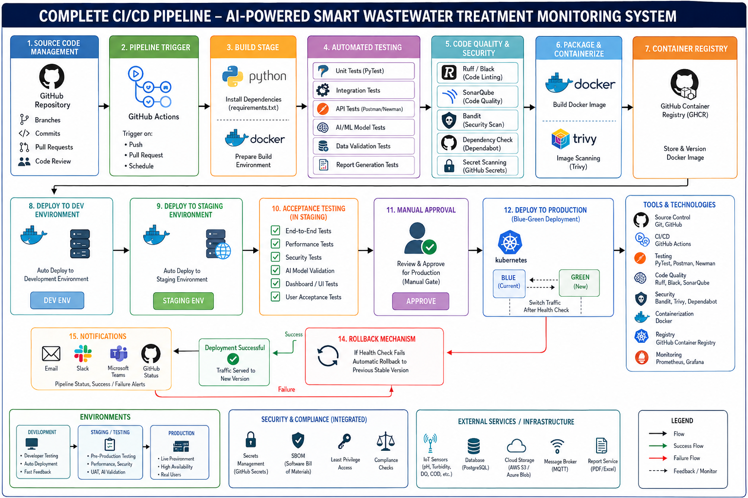

24. Tools and Technologies
CI/CD Stage | Tool | Purpose | Justification
Source Control | Git | Version control | Industry-standard distributed VCS
Repository | GitHub | Code hosting | Supports collaboration and CI/CD
CI/CD | GitHub Actions | Automation | Integrated with GitHub
Backend | Python | Application development | Suitable for AI and data processing
Testing | PyTest | Automated testing | Simple and effective Python testing
API Testing | Postman/Newman | API validation | Suitable for automated API tests
Code Formatting | Black | Formatting | Consistent Python code
Linting | Ruff | Static checks | Fast Python linting
Code Quality | SonarQube | Quality analysis | Detects maintainability issues
Security | Bandit | Python security | Identifies common security problems
Image Security | Trivy | Container scanning | Detects image vulnerabilities
Packaging | Docker | Containerization | Portable deployment
Container Registry | GHCR | Image storage | Integrates with GitHub
Database | PostgreSQL | Data storage | Reliable relational database
IoT | MQTT | Sensor communication | Lightweight messaging protocol
Deployment | Docker Compose/Kubernetes | Container deployment | Supports scalable deployment
Notifications | GitHub/Email/Teams | Pipeline notifications | Provides status updates

25. Example GitHub Actions Workflow
A simplified CI workflow can be designed as follows:
name: Wastewater Monitoring CI/CD

on:
push:
branches:
- main
- develop
pull_request:

jobs:
test:
runs-on: ubuntu-latest

steps:
- name: Checkout source code
uses: actions/checkout@v4

- name: Setup Python
uses: actions/setup-python@v5
with:
python-version: "3.11"

- name: Install dependencies
run: |
pip install -r requirements.txt
pip install pytest

- name: Run tests
run: pytest -v

- name: Code quality check
run: |
pip install ruff
ruff check .

- name: Build Docker image
run: |
docker build -t smart-wastewater:${{ github.sha }} .

- name: Security scan
uses: aquasecurity/trivy-action@master
with:
image-ref: smart-wastewater:${{ github.sha }}
severity: CRITICAL,HIGH
This is a basic example; the final production workflow would additionally require registry authentication, staging deployment, approval gates, production deployment, secrets, health checks, and rollback handling.

26. Branching Strategy
A suitable Git branching strategy is:
main
│
└── develop
│
├── feature/sensor-monitoring
├── feature/ai-prediction
├── feature/dashboard
├── feature/report-generation
└── feature/maintenance-alert
Branch Purpose
Branch | Purpose
main | Production-ready code
develop | Integration and development
feature/* | Individual features
release/* | Release preparation
hotfix/* | Emergency production fixes
Workflow
Feature Branch
↓
Pull Request
↓
Automated CI
↓
Code Review
↓
develop
↓
Staging
↓
Release
↓
main
↓
Production

27. Quality Gates
The pipeline should define quality gates before allowing deployment.
Example Quality Gate
Unit Tests → PASS
Integration Tests → PASS
API Tests → PASS
AI Validation → PASS
Code Quality → PASS
Security Scan → PASS
Docker Build → PASS
Container Scan → PASS
Staging Health Check → PASS
Manual Approval → PASS
If any mandatory gate fails:
Pipeline → STOP → Notification → Fix → Re-run

28. Secrets and Configuration Management
Sensitive information should never be stored directly in the Git repository.
Examples:
DATABASE_PASSWORD
JWT_SECRET
MQTT_PASSWORD
REGISTRY_TOKEN
API_KEYS
These should be stored using GitHub Actions Secrets or an appropriate secret-management service.
The application should access them through environment variables.
Example:
import os

database_password = os.getenv("DATABASE_PASSWORD")
This prevents credentials from being exposed in source code.

29. CI/CD Pipeline Security
Security should be incorporated at multiple stages:
Developer Code
↓
Secret Scanning
↓
Dependency Scanning
↓
Static Security Analysis
↓
Container Scanning
↓
Secure Deployment
Additional security practices include:
- Protecting the main branch.
- Requiring pull-request reviews.
- Using least-privilege credentials.
- Rotating secrets.
- Scanning dependencies.
- Using HTTPS/TLS.
- Restricting production access.

30. CI/CD Workflow for AI Model Updates
Because this project uses AI, model updates should also pass through the CI/CD pipeline.
New Dataset
↓
Data Validation
↓
Model Training
↓
Model Evaluation
↓
Accuracy/Performance Check
↓
Model Versioning
↓
Package Model
↓
Deploy to Staging
↓
Validation
↓
Production
The pipeline should prevent an updated model from being deployed if its performance is significantly worse than the currently deployed model.

31. Justification of the Proposed CI/CD Design
The proposed CI/CD architecture is suitable for the wastewater monitoring system because the project contains multiple components that must work together.
GitHub + Git
Provides:
- Version control.
- Collaboration.
- Branch management.
- Code review.
- Traceability.
GitHub Actions
Provides automated:
- Builds.
- Tests.
- Security scans.
- Docker builds.
- Deployment.
PyTest
Provides automated testing for Python application and AI modules.
Docker
Ensures that the application behaves consistently across development, testing, and production environments.
Trivy and Bandit
Provide security checks for application code and container images.
Staging Environment
Allows the system to be tested before production deployment.
Rollback
Protects production from failed deployments.

32. Expected CI/CD Benefits
Implementing this pipeline provides the following benefits:
Faster Development
Automated testing reduces the amount of manual testing required for every code change.
Improved Quality
Every change is tested before deployment.
Better Security
Security vulnerabilities can be detected early.
Reliable Deployment
Docker provides consistent deployment environments.
Reduced Deployment Errors
Automated deployment reduces manual configuration mistakes.
Easy Rollback
Previous Docker versions can be restored if a deployment fails.
Better Collaboration
Git and GitHub allow multiple developers to work on different modules.
Continuous AI Improvement
AI models can be tested and validated whenever they are updated.

33. Overall Workflow
The complete workflow can be summarized as:
Developer develops feature
↓
Feature branch
↓
Git commit
↓
Pull Request
↓
GitHub Actions triggered
↓
Build
↓
Unit Tests
↓
Integration/API Tests
↓
AI Model Tests
↓
Code Quality Analysis
↓
Security Scanning
↓
Docker Build
↓
Docker Image Scan
↓
Push to Registry
↓
Development Deployment
↓
Staging Deployment
↓
End-to-End Testing
↓
Manual Approval
↓
Production Deployment
↓
Health Check
↓
Monitoring
↓
+---+---+
| |
Pass Fail
| |
▼ ▼
Success Rollback

34. Conclusion
The proposed CI/CD pipeline provides an automated and reliable approach for developing, testing, packaging, and deploying the AI-Powered Smart Wastewater Treatment Monitoring System. The pipeline integrates Git/GitHub, GitHub Actions, PyTest, code-quality tools, security scanners, Docker, and a container registry to automate the software delivery process.
The pipeline begins when a developer commits code to GitHub and proceeds through build, automated testing, AI model validation, code-quality analysis, security scanning, Docker image creation, and container scanning. Successful builds are deployed first to development and staging environments before reaching production.
The inclusion of quality gates, security checks, health checks, notifications, manual production approval, and rollback mechanisms ensures that faulty or insecure changes do not directly affect the production monitoring system. The proposed design also supports future expansion of the system, including real IoT sensor integration, improved AI models, cloud deployment, multi-plant monitoring, and automated treatment optimization.
Thus, the CI/CD pipeline improves software quality, deployment reliability, security, maintainability, scalability, collaboration, and continuous delivery, making it well suited for the proposed AI-powered wastewater monitoring application.

